Visual Programming

Project Report

Objective: Inventory Management System

Submitted by:
Member Name: Wasif Ali Reg. No: 245187
Member Name: Anisa Khan Reg. No: 245215
Member Name: Faiqa Umar Reg. No: 245161
Member Name: Aima Reg. No: 245199

Submitted to:

Ma’am Kaynat

Department of Computer Science
Air University - Aerospace and Aviation Campus, Kamra

Table of Contents

CHAPTER 1: PROBLEM STATEMENT 3
1.1 Statement 3
1.2 Background 3
1.3 Objective 3
1.4 Significance 3
CHAPTER 2: INTRODUCTION 4
2.1 Overview 4
2.2 Motivation 4
2.3 Relevance 4
CHAPTER 3: SYSTEM DESIGN AND METHODOLOGY 5
3.1 System Architecture 5
3.2 Functional Modules 5
3.3 Tools and Technologies Used 5
3.4 Workflow of the System 6
CHAPTER 4: SYSTEM IMPLEMENTATION AND RESULTS 6
4.1 System Design 6
4.2 System Modules 7
4.3 Output Screens 7
4.4 Results 10
CHAPTER 5: TESTING 10
5.1 Introduction 10
5.2 Testing Methodology 11
5.3 Test Cases 11
5.4 Result Analysis 12
CHAPTER 6: CHALLENGES AND LIMITATIONS 12
6.1 Technical Challenges 12
6.2 Implementation Challenges 12
6.3 Limitations of the Current System 13
6.4 Future Improvements 13
CHAPTER 7: CONCLUSION 14
7.1 Summary 14

CHAPTER 1: PROBLEM STATEMENT

1.1 Statement
Many organizations still rely on manual or poorly organized methods to manage their inventory, which leads to inaccurate stock records, difficulty in tracking products, and inefficient order handling. Such systems are time-consuming and prone to errors, resulting in stock shortages, overstocking, and poor inventory control. To overcome these challenges, there is a need for an automated Inventory Management System that can efficiently manage products, users, carts, and orders while ensuring accuracy, security, and ease of use.

1.2 Background
Inventory management is an essential function for businesses dealing with goods and products. With the growth of technology, computerized systems have replaced manual methods to improve efficiency and accuracy. Modern inventory systems help in maintaining product records, tracking stock levels, and managing customer orders in an organized manner. This project focuses on developing a digital inventory management solution to simplify inventory operations.

1.3 Objective
The objectives of this project are:
- To develop a computerized inventory management system.
- To provide secure access for admin and users.
- To manage products, stock, and orders efficiently.
- To reduce manual work and improve accuracy.
- To maintain organized and reliable inventory records.

1.4 Significance
This project is significant as it improves inventory control and reduces errors caused by manual handling. The system saves time, enhances data accuracy, and provides better management of products and orders. It also supports secure data handling and helps users make better decisions through updated inventory information.

CHAPTER 2: INTRODUCTION

2.1 Overview
The Inventory Management System is a software-based application designed to manage and organize inventory-related activities in an efficient and systematic manner. The system allows users to view available products, add items to a cart, place orders, and track their order history. It also provides an admin interface where administrators can manage products and monitor inventory levels. By automating inventory operations, the system reduces manual effort, improves accuracy, and enhances overall efficiency.

2.2 Motivation
The motivation behind developing this Inventory Management System arises from the common challenges faced by organizations using manual or semi-automated inventory processes. These traditional methods often result in data inconsistency, delayed updates, and difficulty in tracking stock and orders. The project aims to provide a simple, user-friendly, and reliable solution that demonstrates how modern software applications can streamline inventory operations while ensuring better control and management of resources.

2.3 Relevance
The Inventory Management System is highly relevant in today’s digital era, where efficient resource management is crucial for business success. Such systems are widely used in retail stores, warehouses, and organizations to maintain accurate stock records and support decision-making. This project not only reflects real-world applications but also helps students understand practical concepts of software development, including user authentication, data handling, and system design, making it both academically and professionally valuable.

CHAPTER 3: SYSTEM DESIGN AND METHODOLOGY

3.1 System Architecture
The Inventory Management System is developed using a component-based architecture. The system is divided into three main modules: User Module, Admin Module, and Core Services Module. The User Module handles product viewing, cart management, and checkout operations. The Admin Module is responsible for managing products and monitoring orders. The Core Services Module manages application state, authentication, and data flow between different components.

3.2 Functional Modules
The system consists of the following major functional modules:
- Authentication Module: Controls user login, registration, and role-based access (Admin and User).
- Product Management Module: Allows the admin to add, update, and view product details such as name, category, stock, and price.
- Cart and Checkout Module: Enables users to add products to their cart, adjust quantities, view cart summary, and confirm orders.
- Order Management Module: Stores order history and allows both users and admin to view placed orders

3.3 Tools and Technologies Used
The following tools and technologies were used in the development of this project:
Tool / Technology | Purpose
C# | Backend logic
Blazor Framework | Frontend and UI development
Visual Studio | Development Environment
.NET | Application runtime
HTML & CSS | Interface design and styling

3.4 Workflow of the System
- User logs in or registers into the system.
- User browses the product catalog and adds products to the cart.
- User proceeds to checkout and confirms the order.
- Order is stored in the system.
- Admin logs in to manage products and view orders.

CHAPTER 4: SYSTEM IMPLEMENTATION AND RESULTS

4.1 System Design
The Inventory Management System has been implemented using C# Blazor for the frontend and application logic. The system follows a component-based architecture where each module is handled by a separate Razor page. Application state is managed using a centralized AppState service which stores product data, cart details, and order records.
The authentication process is handled through an AuthService that manages login, registration, and role-based access control. Users are categorized as Admin or User, and navigation is restricted according to their roles.
The main implemented modules are:
- Login and Registration
- User Product Catalogue
- Shopping Cart with Quantity Controls
- Checkout and Order Confirmation
- Orders History
- Admin Dashboard for Product and Order Management
Each module communicates through shared services to ensure smooth data flow throughout the application.

4.2 System Modules
Module | Description
Login & Registration | Allows users to create accounts and login securely
User Dashboard | Displays product statistics and product catalogue
Product Catalogue | Shows all available products with quantity controls
Shopping Cart | Manages selected items and total calculation
Checkout | Confirms orders and saves them to order history
Orders Page | Displays previous orders
Admin Dashboard | Provides overview statistics for products and orders

4.3 Output Screens
This section contains the output screens of the system including:
- Login Page
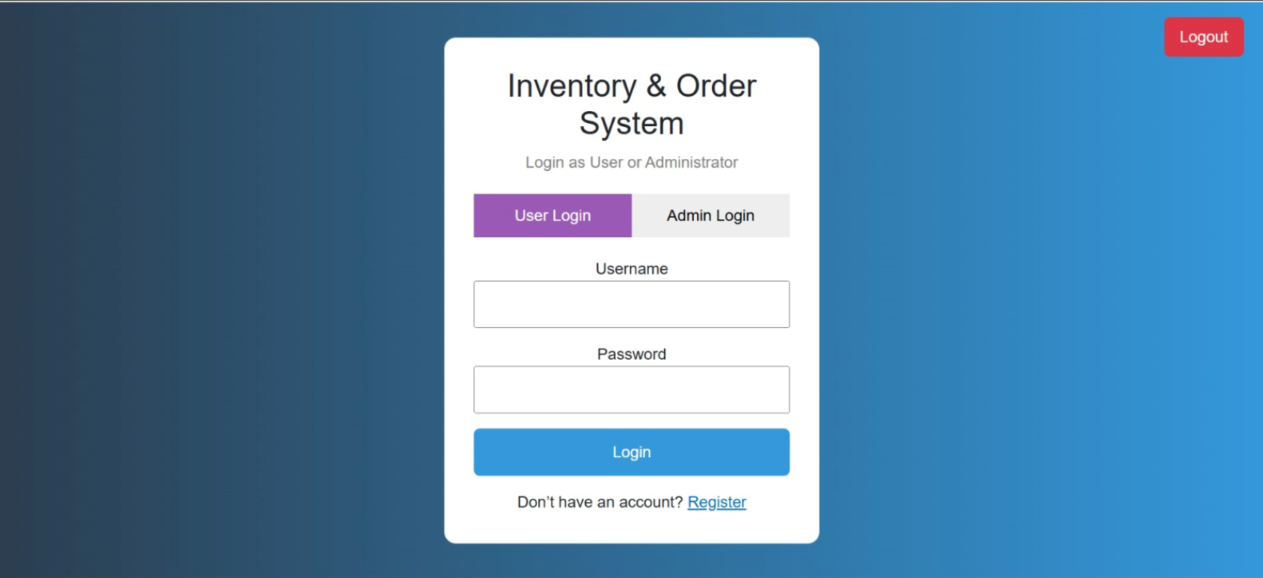
- Registration Page
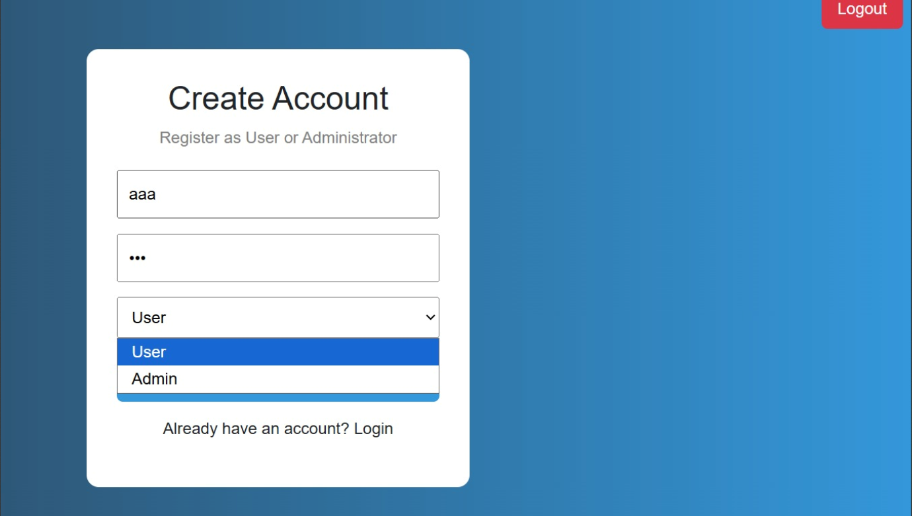
- Product Catalogue
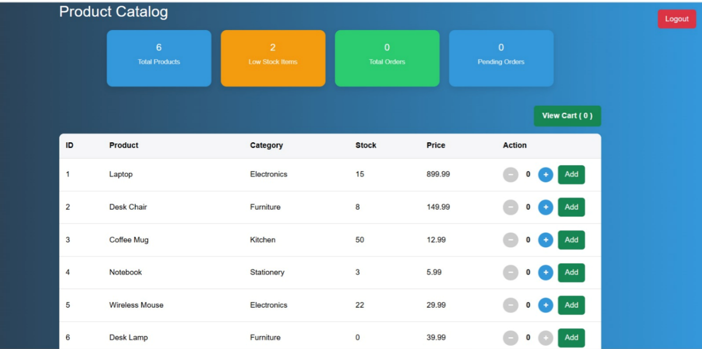
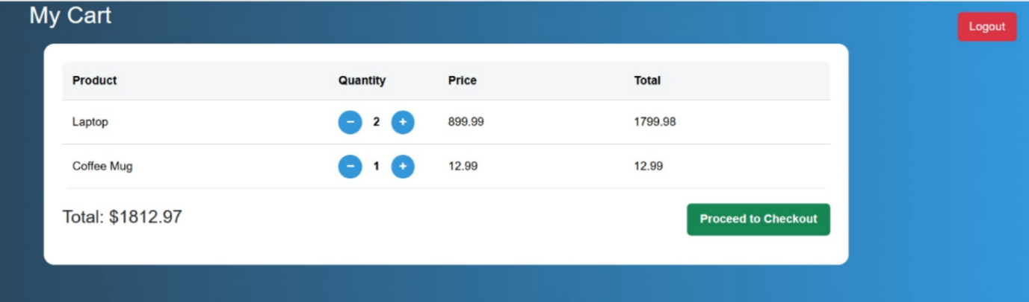
- Shopping Cart
- Checkout Page
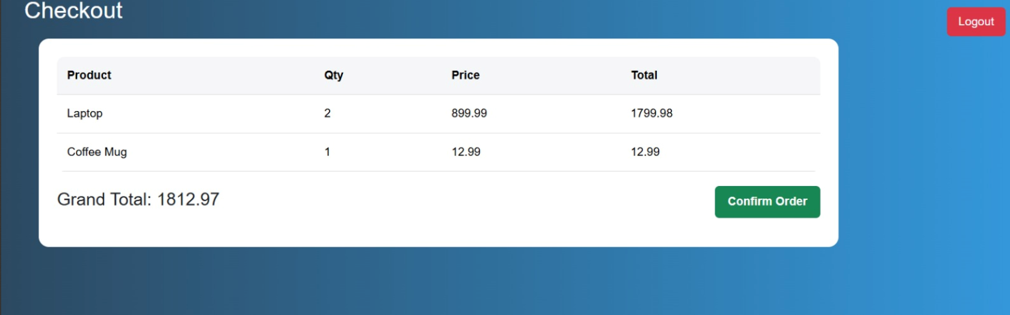
- Orders History
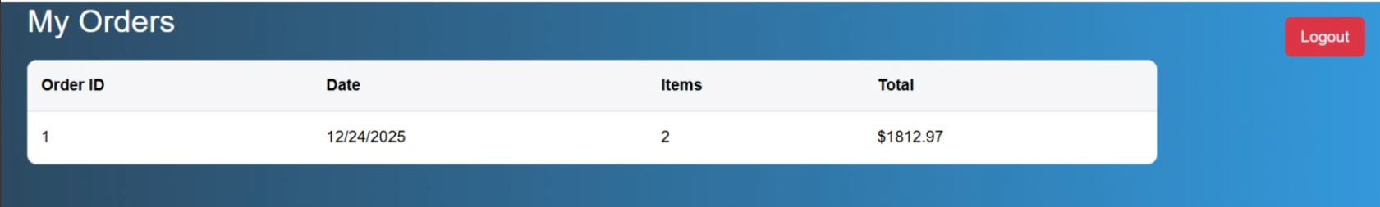

- Admin Dashboard

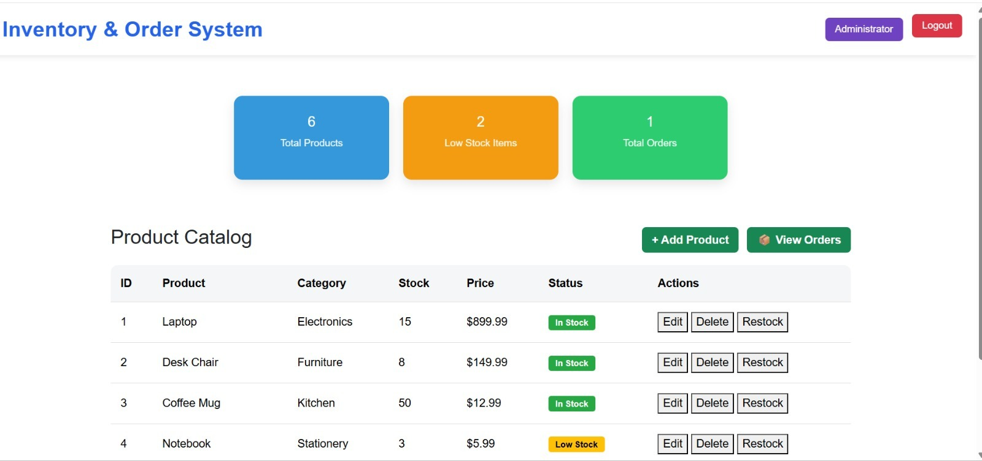

4.4 Results
The system successfully fulfills the objectives defined in earlier chapters. Users can browse products, add items to cart with quantity control, checkout securely, and view their order history. Admin users can monitor product availability and system statistics.
The project demonstrates effective use of object-oriented programming, state management, and role-based authentication in Blazor, resulting in a responsive and user-friendly inventory management solution.

CHAPTER 5: TESTING

5.1 Introduction
Testing is a crucial phase in software development that ensures the system works according to the requirements. In this project, testing was carried out to verify that each module of the Inventory Management System performs its intended function correctly and efficiently. The testing process helped in identifying errors, improving reliability, and ensuring a smooth user experience.

5.2 Testing Methodology
The project was tested using manual testing. Each module was executed separately and then as part of the complete system to verify the integration among different components.
The following types of testing were performed:
- Functional Testing
- User Interface Testing
- Integration Testing
- Validation Testing

5.3 Test Cases
Test Case ID | Module | Test Description | Input Data | Expected Output | Status
TC-01 | Login Module | Login with valid user credentials | Username, Password | User dashboard displayed | Pass
TC-02 | Login Module | Login with invalid credentials | Wrong username or password | Error message displayed | Pass
TC-03 | Product Page | Display product list | Load product page | Product catalog appears | Pass
TC-04 | Cart Module | Add product to cart | Click Add button | Product added to cart | Pass
TC-05 | Cart Module | Increase / Decrease product quantity | Click + / – buttons | Quantity updated correctly | Pass
TC-06 | Checkout | Place order | Confirm checkout | Order saved and cart cleared | Pass
TC-07 | Orders Page | Display order history | Navigate to orders page | Orders list displayed | Pass
TC-08 | Admin Panel | Access admin dashboard | Admin login | Admin dashboard displayed | Pass

5.4 Result Analysis
- All the test cases were executed successfully.
- No critical errors were found in the final version of the system.
- The system accurately performs login authentication, product handling, cart management, checkout processing, and order tracking.

CHAPTER 6: CHALLENGES AND LIMITATIONS
During the development of the Inventory Management System, several technical and practical challenges were faced. Although the system fulfills its basic objectives, certain limitations still exist which can be improved in future versions.

6.1 Technical Challenges
One of the major challenges was working with Blazor components and state management. Managing data across multiple pages such as User Home, Cart, Checkout, Orders, and Admin pages required proper synchronization of the App state service. Errors occurred when objects like Order, Product, or Cart Item were not correctly defined or injected.
Another challenge was handling authentication and role-based access. Differentiating between User and Admin views and ensuring unauthorized users could not access protected pages required extra validation and navigation logic.
Designing a consistent user interface layout across all pages was also difficult. Aligning elements like Logout button, product tables, and action buttons while maintaining responsive design took significant effort.

6.2 Implementation Challenges
Implementing quantity control (+ / – buttons) and updating the cart dynamically was complex. The logic had to ensure that product stock was not exceeded and quantities were reset correctly after adding items.
Adding features like toast notifications, proper navigation flow between pages, and managing UI updates without refreshing the browser also required multiple debugging cycles.

6.3 Limitations of the Current System
Although the system works properly, it still has some limitations:
- Data is stored only in memory, not in a real database. Once the application is restarted, all products, carts, and orders are lost.
- The system supports only basic authentication without password encryption or session handling.
- There is no search, filter, or sort feature for products.
- Admin functionalities are limited to viewing statistics and navigation only.
- Reports, invoice generation, and analytics are not available.

6.4 Future Improvements
In future versions, the system can be enhanced by:
- Integrating a SQL database to permanently store records.
- Implementing secure authentication with hashed passwords.
- Adding advanced Admin features like product creation, update, deletion, and order approval.
- Providing search and filtering functionality for product catalog.
- Adding report generation and printable invoices.

CHAPTER 7: CONCLUSION

7.1 Summary
The Inventory Management System developed in this project provides a simple yet effective solution for managing products, user purchases, and administrative control in a retail-style environment. The system was designed using Blazor with a clear separation of Admin and User roles to ensure security and organized workflow.
The system allows:
- Users to browse products, add items to cart, manage quantities, and place orders.
- Admin to view total products, monitor low-stock items, and track total orders.
- Real-time updates of cart, stock information, and order history.
This project successfully integrates fundamental programming concepts such as object-oriented design, state management, user authentication, and role-based navigation, making it a complete academic-level inventory solution.
Overall, the system achieves its core objectives of reducing manual work, increasing efficiency, and providing a structured digital inventory management platform.

ACKNOWLEDGMENTS
“We would like to express our gratitude to our project supervisor, Ma’am Kaynat & Sir Ghulam Ali, for their guidance and support throughout this project. Additionally, we appreciate the collaborative efforts of our team members in making this project successful.”

